

**Cutting-edge Computer Vision Technique for Brain Tumor Diagnosis**

**Project Proposal**

**By:**

**Name: Jalil Akbarzai**

**Abstract**

Brain tumors continue to pose a significant health challenge, affecting millions of individuals worldwide. The timely and accurate detection of brain tumors is crucial for effective treatment, as it directly influences patient outcomes and survival rates. Traditional methods such as MRI and CT scans are commonly used for tumor detection, but they heavily rely on the expertise of radiologists, which can be time-consuming and prone to human error. The increasing complexity of brain tumors requires more advanced, reliable, and automated diagnostic tools. This project proposes leveraging the latest advancements in computer vision techniques, particularly the YOLOv8 algorithm. YOLOv8 is a state-of-the-art object detection model renowned for its high accuracy, real-time performance, and efficiency in handling complex image data. Its capability to perform object detection in a single pass makes it an ideal choice for automating the process of brain tumor detection from medical images

**Objectives**

* **Primary Objective:** To develop a highly accurate computer vision model using YOLOv8 for automatic detection of brain tumors in MRI and CT images.
* **Secondary Objectives:**
  + To evaluate the performance of YOLOv8 in identifying brain tumors compared to manual interpretations by radiologists.
  + To create a user-friendly application that integrates the YOLOv8 model for clinical use.
  + To assess the model’s reliability, generalizability, and accuracy in various clinical scenarios.

**3. Background and Motivation**

Current methods for brain tumor detection often require extensive manual work from radiologists, which can be inefficient and subject to variability. The integration of deep learning techniques, particularly YOLOv8, offers a promising solution by enabling fast, accurate, and automated tumor detection directly from medical images. YOLOv8’s advanced architecture, with its enhanced object detection capabilities, can provide near real-time detection and localization of brain tumors, reducing the time required for diagnosis and potentially leading to better patient outcomes. This project aims to harness the capabilities of YOLOv8 to improve diagnostic efficiency and accuracy in clinical settings, thereby transforming the way brain tumors are detected and managed.

**4. Methodology**

* **Data Collection:**
  + Gather a diverse dataset of MRI and CT images containing labeled brain tumor data as presented in Figure 1. This dataset can be sourced from publicly available resources like the BraTS (Brain Tumor Segmentation) Challenge dataset or private datasets from hospitals.
  + Pre-process the images, including normalization, augmentation, and quality enhancement, to prepare them for training.

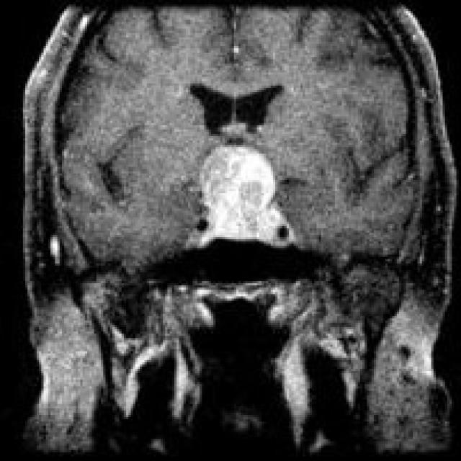

figure 1

* **Model Selection and Training:**
  + Use YOLOv8, the latest version of the YOLO algorithm, known for its improvements in accuracy, speed, and robustness. The model will be fine-tuned on the collected dataset using transfer learning to leverage pre-trained weights and reduce training time.
  + Optimize hyperparameters such as learning rate, batch size, and anchor box sizes to enhance model performance.
  + Implement advanced techniques such as data augmentation and loss function modifications to improve the robustness of the model in detecting brain tumors under varied conditions.
* **Evaluation Metrics:**
  + **Accuracy:** Measure the model's ability to correctly detect brain tumors.
  + **Precision and Recall:** Assess the model’s performance in terms of correctly identifying tumors and minimizing false positives.
  + **Intersection over Union (IoU):** Evaluate the overlap between predicted bounding boxes and ground truth labels.
  + **F1 Score:** To combine precision and recall into a single metric for model evaluation.
* **Deployment:**
  + Develop a web-based application that integrates the YOLOv8 model. The application will enable radiologists and healthcare providers to upload MRI or CT scans and receive real-time feedback on tumor presence.
  + Implement the YOLOv8 model as an API within the application for seamless integration and easy accessibility to healthcare professionals.

**5. Expected Outcomes**

* A reliable and efficient brain tumor detection system using YOLOv8.
* A web-based application for healthcare professionals that can be integrated into clinical workflows to assist in diagnostic decision-making.
* A comprehensive evaluation report comparing the performance of YOLOv8 against manual interpretations by radiologists, demonstrating the model’s accuracy, robustness, and generalizability figure 2 demonstrates the sample of output.

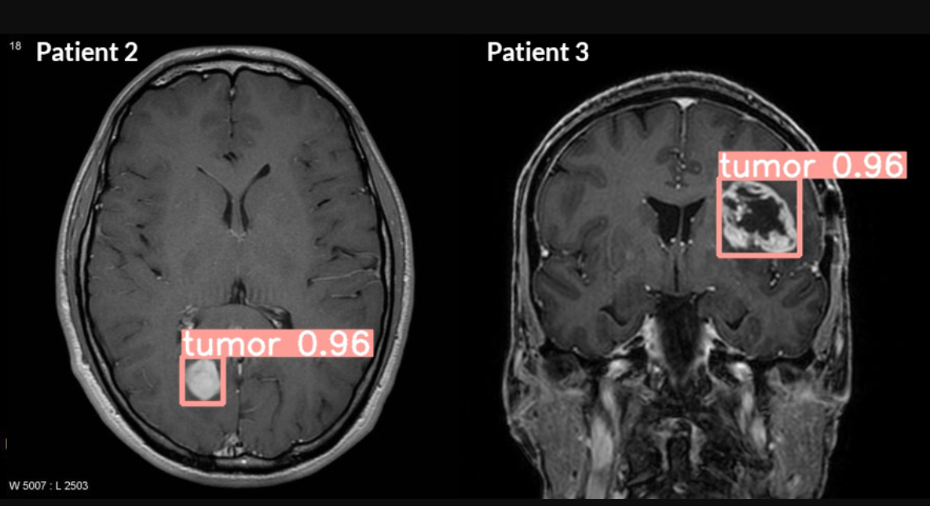

figure 2

**6. Significance**

This project addresses the significant challenges associated with manual brain tumor detection by leveraging the advanced capabilities of YOLOv8. The automated system aims to improve diagnostic accuracy, reduce the workload of radiologists, and enhance patient outcomes. By providing a reliable and efficient tool for tumor detection, this project has the potential to transform the landscape of medical imaging and diagnosis, paving the way for further research and development in AI-driven healthcare solutions.

**7. Conclusion**

The integration of YOLOv8 into brain tumor detection represents a significant advancement in medical imaging. Its real-time, accurate, and automated capabilities offer a promising solution to the challenges faced by radiologists in detecting brain tumors. This project not only aims to enhance the accuracy and efficiency of brain tumor detection but also to provide a valuable tool for clinical practice. By developing a user-friendly application, the project will make advanced AI-driven detection accessible to healthcare professionals, ultimately improving patient care and outcomes in the field of neurology.